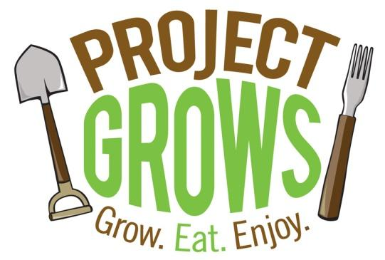
PROJECT GROWS
FARM ASSISTANT
SUPERVISOR: DIRECTOR OF FARM OPERATIONS

Project GROWS (PG) is a 501(c)3 nonprofit educational farm with a mission to improve the overall health of children and youth in Staunton, Waynesboro, and Augusta County, Virginia. We cultivate health by connecting children to nutritious food through 1) hands-on, garden-based education and 2) access to healthy local food.
Project GROWS cultivates 4 acres of mixed vegetables and perennial fruit on our farm in Augusta County, Virginia where we grow 12,000+ pounds of food each year. Our produce is donated or used in educational programs, and the remaining is sold: to members, at farmer’s markets, and wholesale to restaurants in order to sustain our programming. Project GROWS manages a 20-member Community Supported Agriculture (CSA) program and two local farmers markets (North Augusta and Waynesboro farmers markets). Both of our markets accept SNAP benefits (supplemental nutrition assistance program) and offer double dollars programs for families using their SNAP at market. We hold a youth-run farm stand in partnership with the Boys & Girls Club, and a Health Department farmers market serving families participating in the WIC program (women and infant children). We serve over 3,000 local youth each year with gardening, nutrition, and cooking education, and partner with 22 local agencies on food programs including field trips, summer camps, and farm to school tastings.
General Statement of Responsibilities

The Farm Assistant will work closely with all members of the PG team including the PG Executive Director, Director of Farm Operations, Associate Director of Farm Operations, Director of Education and the Director of Food Access. In addition, the Farm Assistant will work closely with AMI fellow(s) placed with PG for phase II of the fellowship program, college interns, and summer youth staff. The Farm Assistant will directly assist the Director of Farm Operations with all aspects of fruit and vegetable production at the farm including: research, crop planning, planting, harvesting, weeding, pest management, irrigation, post-harvest handling, deliveries, sales, and leading volunteer groups.

In addition to on-farm production responsibilities, the Farm Assistant will participate in

- garden, nutrition, and cooking education as needed
- coordinating, scheduling, and directing volunteers
- farm tool repairs and light building projects
- maintaining organization of tools and supplies
- community events & education outreach with partner organizations as needed
- farmer’s markets
- special events
- administrative tasks as needed

Applicants must possess a strong work ethic, be willing to learn and be able to work efficiently and follow direction. Applicant must be able to lift 50+ pounds regularly and be comfortable working outside including during hot, cold, and inclement weather. Experience with tools and experience working on a vegetable farm are helpful, but a willingness to work hard and try new things is most important. Preferred experience and knowledge of working with children and youth from diverse backgrounds. Has intimate knowledge of the flow of a full season in a production garden. Must possess strong interpersonal skills and an ability to manage various community relationships.

Other Requirements:

- Cell phone communication
- Reliable transportation
- A valid driver’s license
- Criminal background checks will be required for final applicants

Compensation:
This is a part-time, seasonal 24 hours per week position beginning August and ending October 30th. Salary is $9-$12 per hour commensurate with experience. This position may require occasional weekend and/or evening work. Project GROWS is an education-based farm. We are interested in teaching the farm assistant the values and techniques required to manage/run a small farm.

Educational Goals of Farm Assistant:

- To share the skills and knowledge involved in sustainable farming.
- To offer farm assistant an example of a successful organic farm so that they can learn the cycles of the growing season, crop rotation, succession/companion planting, and market farming.
- To give farm assistant first hand working knowledge with specific crops, so that they can have a solid foundation of farming experience.
- To support the hands-on learning that comes through hard work in the fields with educational resources and leadership opportunities.
- To gain experience working with and facilitating youth groups and volunteers at the farm.
HOW TO APPLY:
Please email Director of Farm Operations, Laura Faircloth, laura@projectgrows.org with a cover letter and resume.

For more information about Project GROWS: www.projectgrows.org

