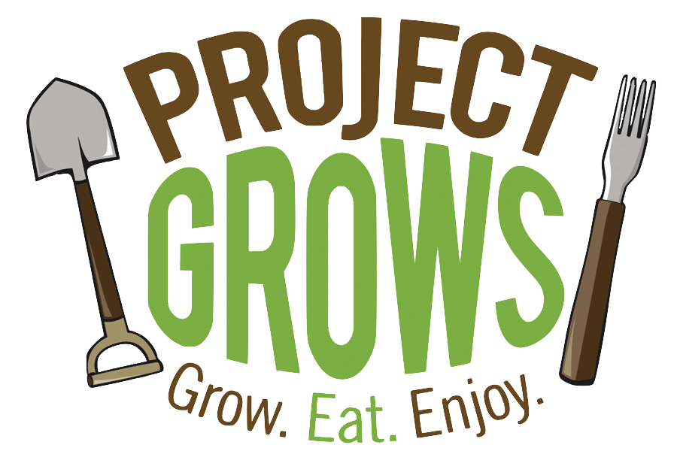
Fall 2020 Video Production Internship
Part-time, volunteer internship for Project GROWS
10 hours/week, September 1st - December 3rd, 14 weeks total
Combination of remote and in-person work

Organization Overview: Project GROWS (PG) is a 501(c)3 nonprofit educational farm with a mission to improve the overall health of children and youth in Staunton, Waynesboro, and Augusta County, Virginia. We cultivate health by connecting children to nutritious food through hands-on, garden-based education and access to healthy local food. To see our COVID-19 Online Education Series, visit www.projectgrows.org/blog.

Position Overview: Since our typical in-person field trips to our farm and our school gardening programming have been suspended, we have pivoted our efforts towards delivering online content. We are seeking an intern who can collaborate with the Food Education programming team at a minimum of 10 hours per week during Fall 2020 (September through early December) to produce short educational videos to deliver garden and nutrition education programming to teachers and students in Staunton City Schools and Waynesboro Public Schools as well as to parents who are facilitating virtual learning for their children at home during COVID-19 modified school openings.

Commitment:
Fall 2020 (Starting early September and ending early December). Hours will be arranged based on applicant’s availability and/or desired credits, but will be between approximately 140 total hours. *Note that no hours will be required during the week of Thanksgiving or the week of final exams.*

Compensation:
- This is an unpaid internship. Please state in your application if you are looking to receive course credit.
- All interns are given a share of farm produce during the growing season!

Responsibilities:
- Meet weekly via videoconference with our Food Education team to plan our monthly video (Google Hangouts)
- Film cooking and gardening nutrition and edit video footage using editing software (Editing software of choice)
Note that the responsibility for filming is shared by the whole team, but you will film segments for each video. Because of COVID-19 restrictions, ideally this would involve you filming yourself!
- Upload videos to social media and where possible, edit closed captions for accuracy (Facebook, YouTube)
- Participate in a minimum of three on-farm team meeting / work days (3 hours each)

Requirements:
- Software: Video editing software (KDenLive and OpenShot Video Editor are wonderful free options for PC users)
- Equipment: Working laptop and smart phone with video and camera capabilities. Good internet connection needed at home in order to work remotely.
- Schedule: Can commit to a regular weekly schedule that aligns with program dates and times
- Transportation: A valid driver’s license and reliable transportation for in-person filming and team meetings.
- Other: Comfortable working outside;, able to pass a criminal background check

Desired qualifications:
- Experience working with video editing software preferred
- Experience gardening or working with youth is a plus!
- Interest in nutrition, school gardening, child health, local food, agriculture, youth engagement, etc.

To apply please send this application and a cover letter to Nichole Barrows,
Director of Education, at nichole@projectgrows.org.

2020 Internship Application
Contact Information

Name: _______________________________________________

Address: _____________________________________________________________

Phone number: _____________________________

Email address: ________________________________________

University or College Name: ______________________________________________

Graduation date (planned): ____________________ Major(s): _______________________________________

Skills and Interests
1. Why are you interested in this position?

2. Why do you think you are a strong candidate for this position?

3. What relevant knowledge or skills do you bring to Project GROWS? (We’re specifically curious about any gardening, farming, outdoor, equipment maintenance, tools, or leadership experience you might have, but feel free to share more broadly!)

4. Please write the blocks of time each day of the week that you would be available to work at the Project GROWS farm during the summer between September 1 and December 3.

Mondays | Tuesdays | Wednesdays | Thursdays | Fridays

PLEASE SEND COMPLETED APPLICATION AND COVER LETTER TO NICHOLE@PROJECTGROWS.ORG

Project GROWS | www.projectgrows.org | Mailing address: P.O. Box 781, Staunton, VA 24402
Farm address: 608 Berry Farm Road, Verona, VA 24482

