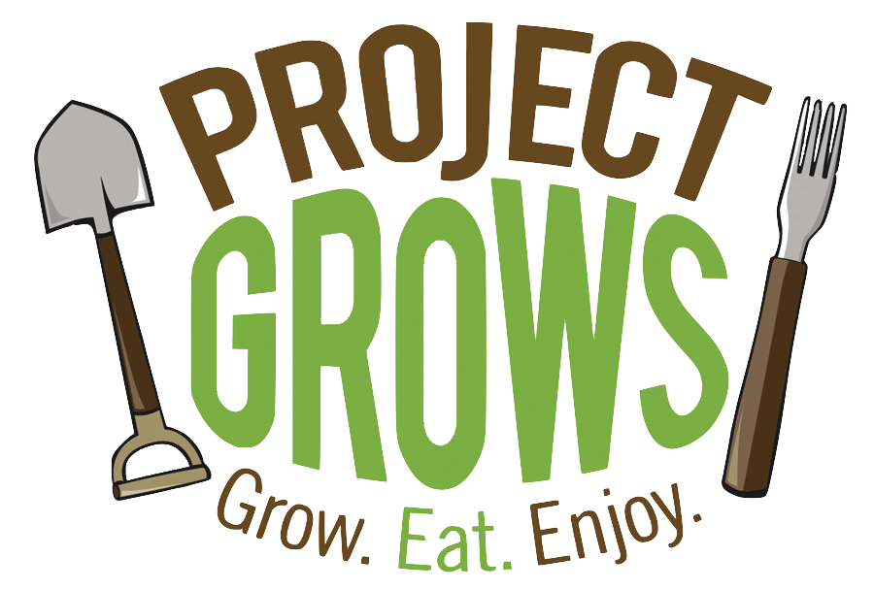
Fall 2020 Farm to School Internship
Part-time, volunteer internship for Project GROWS
10 hours/week, September 1st - December 3rd, 14 weeks total
Combination of remote and in-person work

Organization Overview: Project GROWS (PG) is a 501(c)3 nonprofit educational farm with a mission to improve the overall health of children and youth in Staunton, Waynesboro, and Augusta County, Virginia. We cultivate health by connecting children to nutritious food through hands-on, garden-based education and access to healthy local food. To see our COVID-19 Online Education Series, visit www.projectgrows.org/blog.

Position Overview: Since our typical in-person field trips to our farm and our school gardening programming have been suspended, we have pivoted our efforts towards delivering online content and delivering Cooking at Home kits to local partner organizations who provide after-school care. We are seeking an intern who can collaborate with the Food Education programming team at a minimum of 10 hours per week during Fall 2020 (September through early December) to coordinate the marketing launch of our monthly videos; film a segments for each video; and create print content about gardening and cooking to be included with Cooking at Home kits for children

Commitment:
Fall 2020 (Starting early September and ending early December). Hours will be arranged based on applicant’s availability and/or desired credits, but will be between approximately 140 total hours. *Note that no hours will be required during the week of Thanksgiving or the week of final exams.*

Compensation:
- This is an unpaid internship. Please state in your application if you are looking to receive course credit.
- All interns are given a share of farm produce during the growing season!

Responsibilities:
- Meet weekly via videoconference with our Food Education team to plan our monthly video (Google Hangouts)
- Write short video scripts (Google Docs) and blog posts (WordPress) that feature our vegetable of the month
- Film short cooking and gardening segments for monthly video
- Design graphics and posters to creatively present educational content to children (Canva)
- Design emails to send the video and materials to teachers and parents (Mailchimp)
- Participate in a minimum of three on-farm team meeting / work days (3 hours each)

Requirements:
- Can commit to a regular weekly schedule that aligns with program dates and times
- Working laptop and smart phone with video and camera capabilities.
- Good internet connection needed at home/school
- A valid driver’s license and reliable transportation
- Excellent spelling, grammar, and punctuation skills
- Comfortable working outside
- Able to lift 50 pounds
- Able to pass a criminal background check

Desired qualifications:
- Interest in nutrition, school gardening, child health, local food, agriculture, youth engagement, etc.
- Experience with Mailchimp and Canva preferred but not required- we can teach you! Willingness to learn is the most important skill we are looking for.
- Comfortable juggling a variety of tasks; organized, and self-motivated

To apply please send this application and a cover letter to Nichole Barrows,
Director of Education, at nichole@projectgrows.org.

2020 Internship Application
Contact Information

Name: _______________________________________________

Address: _____________________________________________________________

Phone number: _____________________________

Email address: ________________________________________

University or College Name: ______________________________________________

Graduation date (planned): ____________________ Major(s): _______________________________________

Skills and Interests
1. Why are you interested in this position?

2. Why do you think you are a strong candidate for this position?

3. What relevant knowledge or skills do you bring to Project GROWS? (We’re specifically curious about any gardening, farming, outdoor, equipment maintenance, tools, or leadership experience you might have, but feel free to share more broadly!)

4. Please write the blocks of time each day of the week that you would be available to work at the Project GROWS farm during the summer between September 1 and December 3.
Mondays | Tuesdays | Wednesdays | Thursdays | Fridays

PLEASE SEND COMPLETED APPLICATION AND COVER LETTER TO NICHOLE@PROJECTGROWS.ORG

Project GROWS | www.projectgrows.org | Mailing address: P.O. Box 781, Staunton, VA 24402
Farm address: 608 Berry Farm Road, Verona, VA 24482

